# Assessing risks to Antarctic terrestrial and nearshore ecosystems

Australian Antarctic Science Grant Project no 4568

Annual report 2020

## Introduction and Project summary

Despite being one of the most remote environments on the planet, threats to Antarctic ecosystems are escalating. Threats include increasing human activity, pollution, biological invasions and a changing climate. Therefore, understanding more about the vulnerability of Antarctic environments, and identifying areas that warrant increased management or policy focus are becoming increasingly important. The Red List of Ecosystems protocol was developed in response to a growing demand for ecosystem-level risk assessment and has been adopted as a global standard by the International Union for Conservation of Nature (IUCN). Globally, this method has been successfully applied across a range of environments with tangible conservation outcomes, however, to date its application to Antarctic ecosystems has been limited. We will deliver a continent-wide risk assessment of Antarctic terrestrial and nearshore ecosystems, to inform conservation planning, management and policy development in the region.

The primary goal of this research is to establish a solid foundation for a systematic assessment of risks to Antarctic terrestrial and nearshore ecosystems as a basis for securing biodiversity into the future under a changing environment. To achieve this goal, we aim to:

1) Develop a typology and spatial distribution models for terrestrial and near-shore Antarctic ecosystems;

2) Develop generic diagnostic models for functional groups of ecosystems represented in the typology (via elicitation workshop)

3) Compile relevant data sets and undertake a gap analysis to identify the additional data needed for a comprehensive systematic ecosystem risk assessment; and

4) To significantly expand the suite of Antarctic ecosystem risk assessment case studies by applying the IUCN Red List of Ecosystems criteria to a selection of ecosystem types for which suitable data sets are available.

The approved project proposal identified for phases of the work program. This report details progress on phase 1 of the project, which comprises five components.

Phase 1

1a) Develop data management plan

1b) Recruit post-doctoral fellow

1c) Review and compile available data sets

1d) Develop ecosystem typology

1e) Commence distribution modelling for ecosystem types

## 1a. Data Management Plan

The Data Management Plan was submitted on 24 April 2020. The plan identifies four data products as detailed in the table below.

| **Product name** | **Product description** | **Data volume** | **Delivery date** |
| --- | --- | --- | --- |
| Antarctic Ecosystem Functional Models | A series of diagnostic models that identify key ecosystem components, processes, threats, and state variables that outline functional definitions of ecosystem collapse. | 10 MB | Dec 2020 |
| Antarctic Ecosystems Indicator Dataset | Collection of datasets that serve as indicators of ecosystem collapse for the ecosystems in the functional typology. Dataset will include information about missing data for ecosystems that do not have enough data for collapse risk assessment. | 500 MB | Jun 2021 |
| Risk Assessment for Antarctic Ecosystems | A series of model and written outputs detailing (A) Reduction in geographic distribution, (B) Degree of restriction in geographic distribution, (C) Environmental degradation, (D) Disruption of biotic processes, and (E) Quantitative analyses that estimates the probability of ecosystem collapse for Antarctic ecosystems that have adequate data. Partial assessments may result for ecosystems with sufficient data to assess some criteria but not all. | 500 MB | Mar 2022 |
| Antarctic Ecosystem Functional Typology | A map or maps of Antarctica delineating the functional typology of non-ice-covered and nearshore ecosystems, accompanied by ecosystem descriptive profiles according to the IUCN Red List of Ecosystems guidelines. | 250 MB | Dec 2020 |

The four data products will be archived in the Australian Antarctic Data Centre.

## 1b. Post-doctoral fellow

Dr Aniko Toth was identified as the post-doctoral fellow to carry out the project work program in November 2019. Dr Toth has advanced ecological modelling skills and experience in analysis of big data. She commenced work on the project in February 2020 after building experience in the IUCN Red List of Ecosystems protocol in collaborative projects on Finnish mire ecosystems and Australian alpine ecosystems.

## 1c. Review and compilation of data sets

Data compilation has focussed on spatially explicit data required to develop the ecosystem typology. The data sets compiled for analysis include:

i) Biogeographical spatial layers;

ii) Biological occurrence records;

iii) Distribution models for selected taxonomic groups;

iv) Ecological time series;

v) Landscape variables derived from radar imagery, including elevation, rugosity, solar radiation, elevation, slope, aspect and ice-free areas;

vi) Climate data including temperature, precipitation, wind and derived climate products.

Different data sets are available in different spatial resolutions. Biotic distribution models are available in large pixels, environmental data are available in small pixels, ice-free areas are available as polygons, while occurrence records for biota are point records.

## 1d. Development of the ecosystem typology

The project team agreed on an aim to develop a terrestrial ecosystem typology with no more than 100 units, ideally 40-60. We explored alternative approaches to developing a typology from available data.

We first explored co-occurrence clusters in the biological occurrence records using a presence-absence matrix of species presence-absence by ice-free areas for each of five decades (1960-2010). The data were cleaned to remove records representing uncertain identifications at the species level, and ice-free areas and species with less than five records in a given decade. A two-stage co-occurrence and cluster analysis produced three general assemblage types which exhibit some overlap in composition: one with 154 taxa dominated by fungi, cyanobacteria, and some mosses, also with Ochrophyta, Rotifers, Tardigrades, Chlorophyta, some arthropods and Adelie penguins occurring across the Antarctic mainland, and occasionally on the peninsula; a second group with 122 species dominated by (presumably mostly different) fungi and mosses, but also including chinstrap and gentoo penguins, found only on the Antarctic peninsula and nearby islands; and a third group with 73 species dominated by vertebrates (all penguins, seabirds, and pinnipeds), along with an apparently complimentary suite of arthropods, nematodes, and mosses, found only on the peninsula. Many ice-free patches could not be characterised due to insufficient sampling. An appraisal of temporal patterns indicated that individual ice-free patches supported different assemblages in different decades, likely a reflection of sampling campaigns that targeted different taxa. We concluded that this approach produced outcomes that were sensitive to sampling patterns.

Second, we explored modelled distributions for 34 functional groups of taxa. Large pixels across the continent were attributed with suitability values for each taxonomic group, enabling application of a c-means clustering algorithm and display on Principal Co-ordinates visualisation with linear vectors representing suitability for the modelled taxa in two dimensions (Fig. 1). The results suggest a highly nested structure of the biota, with nested clusters strongly aligned with a single gradient (Fig. 1), which proved to be unrelated to environmental-based clusters (Fig. 2). Although all pixels could be classified with this approach, like the occurrence analysis, the role of sampling 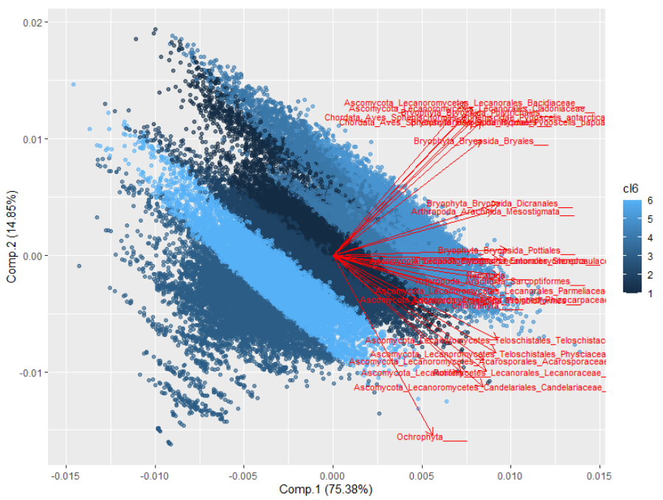biases in this outcome could not be dismissed. Furthermore, we were concerned that the clusters represented only the main nestedness gradient, drowning out the signal from more uniquely distributed functional groups, and failing to represent environmental conditions.

**Figure 1**. C-means clusters (shades of blue) superimposed on Principle Co-ordinates visualization with linear vectors representing modelled habitat suitability for taxonomic groups.

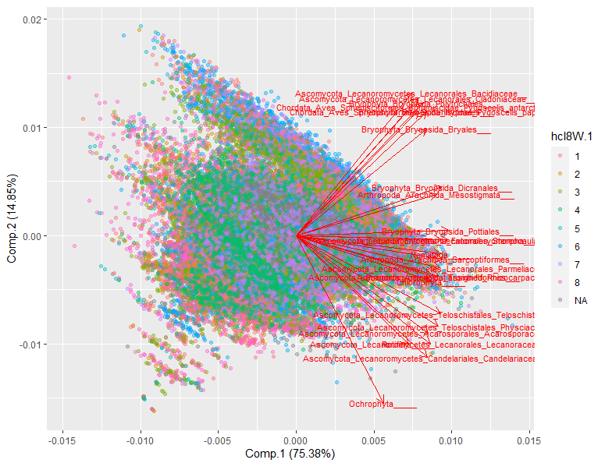

**Figure 2**. As for Fig. 1 but with environmental clusters superimposed (see Fig. 3)

Third, we explored weighted c-means clustering of small pixels based on six uncorrelated environmental variables (wind speed, precipitation, days below -5°C, elevation, rugosity, and distance from coast). Groupings proved to be unstable with different initial seed configurations for the c-means algorithm.

Third, the c-means cluster analysis was repeated with upscaled environmental data based in larger pixels with 8 centres. This produced environmental clusters which proved to be relatively stable over multiple random initial configurations of the cluster seeds (Fig. 3). To confirm this stability, we ran 100 independent c-means classifications with 8 randomly placed starting centres each time. From the results, we identified clusters that occurred recognisably in a majority of the 100 runs. Although the exact boundaries between the clusters varied between runs, we were able to identify seven consistently occurring habitat types using this consensus approach. Each pixel was then classified by the habitat in which it was most frequently placed.

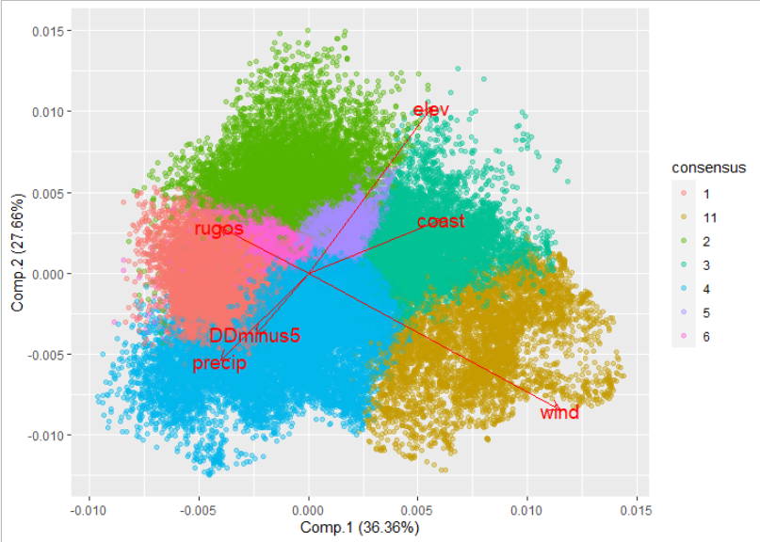

**Figure 3**. Principal Co-ordinate ordination of ice-free large pixels, with linear vectors representing variation in six environmental variables across seven environmental clusters represented by different colours, produced using the consensus approach.

We then intersected the consensus-based environmental clusters with 15 Antarctic biogeographic regions based on an update of an earlier regionalisation by Terauds et al. (2016) (Fig. 4), excluding the South Orkney Islands bioregion.

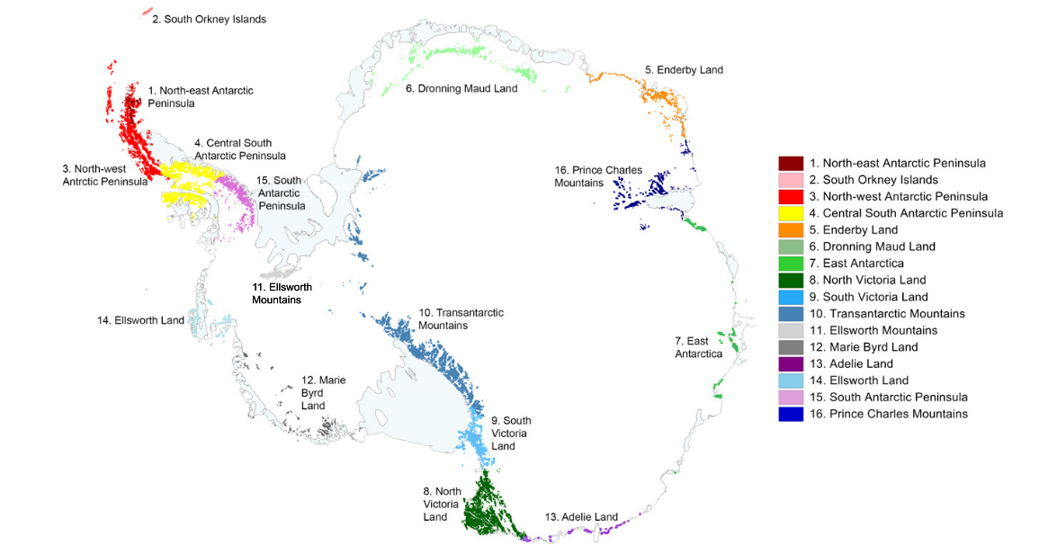

**Figure 4**. Maps of 16 Antarctic terrestrial biogeographic ice-free regions (based on Terauds et al. 2016).

This produced more than 80 unique mappable combinations of environmental cluster and bioregion (Fig. 4) represented across the continent, with some combinations not represented at all and others represented only by a small number of pixels. All candidate units will be attributed with species records appraised by experts and examined on google earth imagery to assess their efficacy, with smaller groups lumped with environmentally similar candidates where distinctions appear weak.

Several thousand pixels were initially unassigned because they lacked the requisite environmental data to be classified using the consensus approach. Of these, many included small offshore islands and coastal pixels. Separate units were created for small offshore islands (< 1 square km), medium offshore islands (1-100 square km), and large offshore islands (> 100 square km). Remaining unclassified pixels were classified using similarity in SDM suitability surfaces and proximity to nearby units. These pixels had to be within 100 km of a unit and exhibit at least 98% similarity to that unit to be lumped into that unit. Remaining pixels were classified with their nearest neighbours, if these were within 6 km of the focal pixel. Pixels which could not be classified using these stringent limitations were left unclassified (about 250 pixels).

## 1e. Distribution modelling for ecosystem types

The approach described above enables coincident mapping of ecosystem types derived from the spatial analysis of environmental clusters in relation to biogeographic regions. A map of candidate habitat classifications is shown in Fig. 5 and a map of candidate units is shown in Fig. 6, prior to rationalisation by expert appraisal.

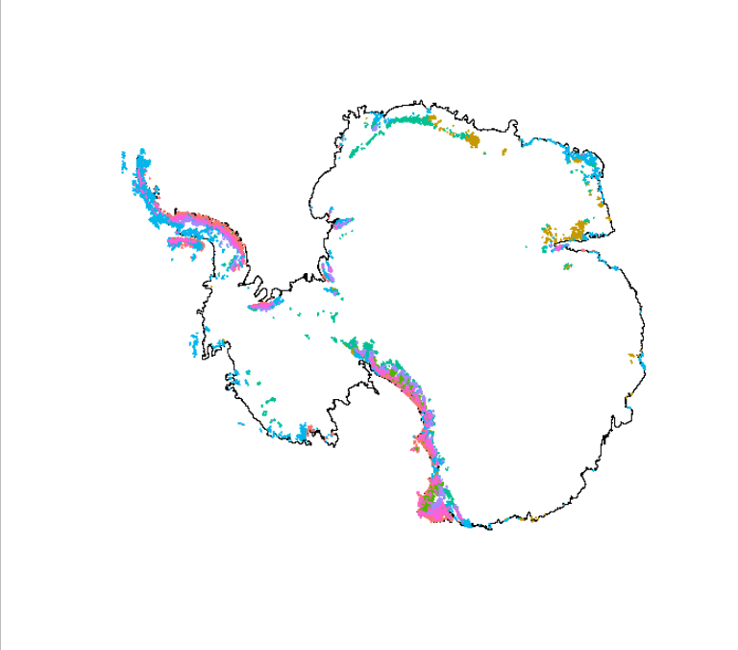**Figure 5**. Consensus habitat types on a map of the Antarctic mainland. Colours correspond to Fig. 3.

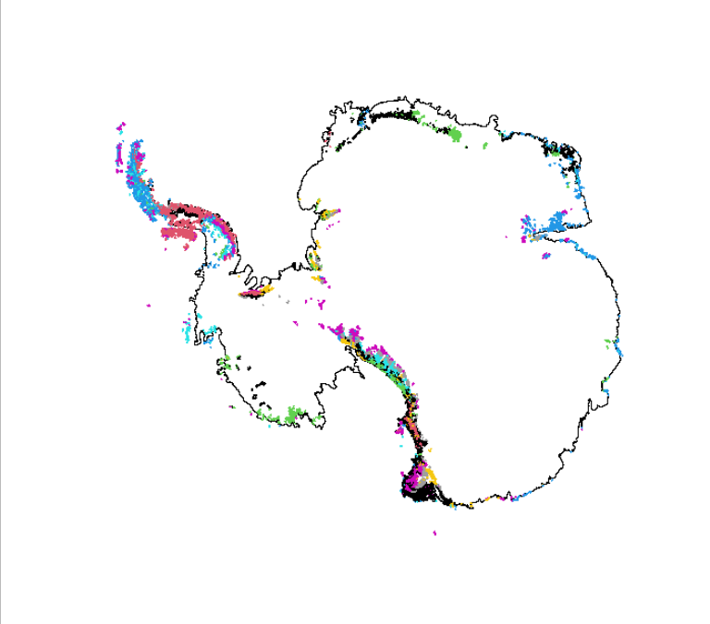**Figure 6**. Candidate ecosystem types derived from intersection of environmental clusters with biogeographic regions (colours repeat to represent 70+ units).

## Next steps

In phase 2 we will arrange expert elicitation to rationalise the units of the ecosystem typology and describe their biological and environmental attributes.

## Progress against approved application & MER

…. Timeframes met and reasons for delays, proposed corrective action, impact on milestone, other objectives, completion

## Summary of Progress on Project Milestones

|  |  |  |
| --- | --- | --- |
| **Milestone** | **Date** | **Status** |
| 1 Agreement signed | 25 November 2019 | Complete |
| 2 Initial payment |  | Complete |
| 3 Data Management Plan | Acceptance prior to 25 May 2020 | Submitted 24 May 2020 |
| 4 Annual report 2019-20 | June 2020 | This report |